**Workflow Design Documentation**

**Business Term Approval Workflow**

**Application Version History**

|  |  |  |  |  |
| --- | --- | --- | --- | --- |
| **Application Version** | **Released On** | **Released By** | **Changelogs** | **Approved By** |
| 1.0 | 28-07-2020 | N. Padma Gokul | - |  |
| 1.1 | 03-08-2020 | N. Padma Gokul | Changed workflow design based on feedback from review |  |

# **Contents**

[**1. Overview**](https://docs.google.com/document/d/1DqVuA1M_ofZBnRHXTiHPNxzSvBHyPwH02r1RRQ9LkbE/edit#heading=h.abc46wlrpe73)[**4**](https://docs.google.com/document/d/1DqVuA1M_ofZBnRHXTiHPNxzSvBHyPwH02r1RRQ9LkbE/edit#heading=h.abc46wlrpe73)

[**2.**](https://docs.google.com/document/d/1DqVuA1M_ofZBnRHXTiHPNxzSvBHyPwH02r1RRQ9LkbE/edit#heading=h.iddpw8zdr21g) **Workflows 4**

**3. Appendix 7**

# **Overview**

This document provides a visual representation of the workflows that are involved in the business term approval workflow. The workflows are provided here with the description of them for further understanding of the process.

# **Workflows**

### **2.1 Propose Business asset workflow**

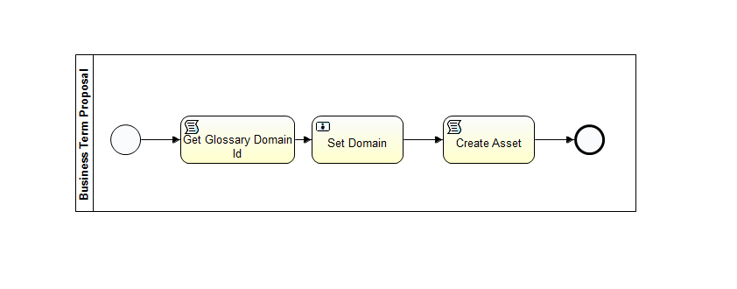

**Workflow Explanation**

* The workflow starts when the user clicks the button ‘Propose Business Term’. It provides a form to the user to fill in the required information, such as name, domain, reason for proposal etc.
* Then the script task is executed and the asset is created in a temporary domain.

### **2.2 Approval Workflow**

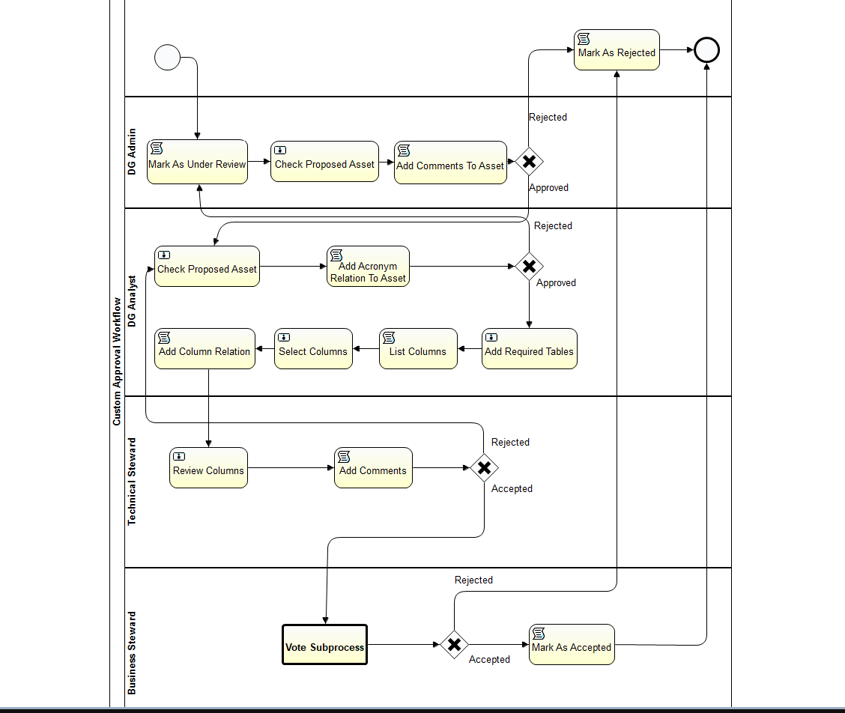

**Workflow Explanation**

* This workflow is either triggered automatically or can be started by going into the created asset in the temporary domain.
* Now the asset is marked as ‘under review’. At first the DG admin checks the asset and either accepts or rejects the asset. If accepted, the admin provides a comment for the asset and the process moves to DG analyst.
* If rejected, the approval process starts again after the start user makes the necessary changes as mentioned in the rejection comment.
* The DG admin can also change the domain of the asset.
* Now the process moves to the DG analyst and they go through the previous comments and the asset as well.
* If accepted, the analyst provides a comment for the asset and also provides the relationship to an acronym if it exists.
* The DG analyst can also change the domain of the asset.
* After submitting the comment, the DG analyst is presented with the form to enter the source table asset.
* They can select necessary columns from the table. The business term asset can have more than one column with different source table assets and is displayed with the column name and its link to the source.
* The relationship is added after the analyst submits the form and the process moves to technical steward.
* The technical steward reviews the columns and provides comment, rejects or accepts the column relationship.
* Then the process moves to the business stewards and the voting process starts.
* If enough votes are gained, then the asset is approved and is moved to the target domain. Else the process repeats again.

### **2.3 Voting Subprocess Workflow**

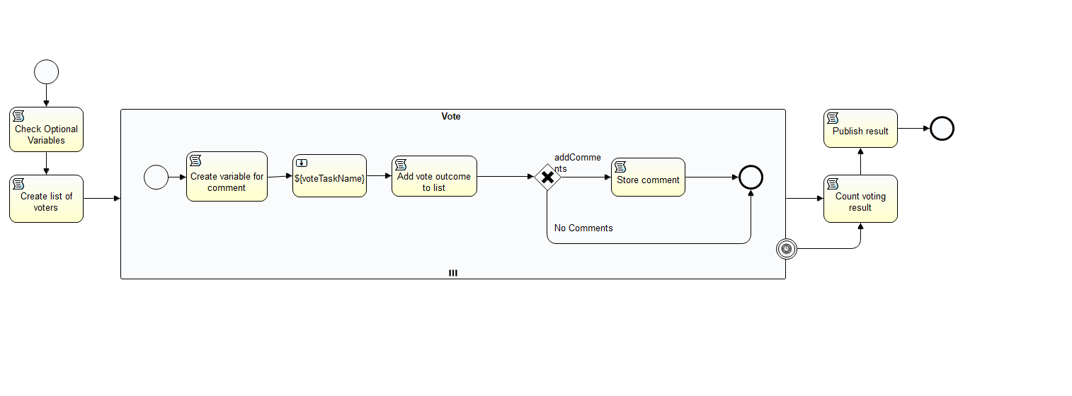

**Workflow Explanation**

* This subprocess is started when the process enters the business steward lane.
* It collects the votes from all the business stewards and based on the votes received, the asset is approved or rejected.
* The deadline for voting can be provided.

# **Appendix**

* DG - Data Governance